CHAPTER ONE
1.0 INTRODUCTION
Simple rosters are used in some form by people all over the world, in any situation in which a group of individuals seek to perform some routine task on a rotational basis. They provide a way for people to schedule which individual in a group will be responsible for a given task at a particular time.
Due to the nature of these kinds of rosters in representing a diverse range of different activities in varying time frames, most rosters today are simply printed or drawn by hand on paper. There is currently a shortage of digital roistering tools to facilitate the creation and sharing of these kinds of rosters.
There is an opportunity for a system to be developed that will fill this void and bring simple rosters into the digital age. Most participants in any roster today will have regular access to email and a web browser, particularly in an office environment. The near-ubiquitous nature of these facilities in today's society presents an opportunity for a web-based roster system that is far superior to existing systems in terms of ease of use, convenience, and accessibility.
The duty allocation system is a web-based roster system that was created over the course of this project to take advantage of the opportunity described above. It is targeted toward a wide variety of simple roster scenarios, such as the following:
- Routine tasks in an office,
- Shared roles in jigawa radio staffs, and
- Odd jobs around the house.
The allocation system will provide a simple, flexible, and accessible web-based interface through which admin can create and modify rosters (if authorized to do so), as well as view them and configure notifications for both staffs. The system will feature the following:
- Flexible roster options to suit a variety of tasks,
- Email confirmations and notifications, and
- Authentication and authorization of users.
1.1 STATEMENT OF THE PROBLEM
Many of the radio station use to create their duty manually for their journals. Which causes many problems especially by assigning multiple programs to exceed the staff time limit and profession? Most of time when listening radio we may hear the caster make a lot of mistake usually due to tiredness and stress. This is because he attempts multiple programs beyond the exact time being arrange.
This system provides all of the necessary functionality for creating, modifying, and sharing list of programs in the station to the staff, but there are many improvements yet to be made that will improve efficiency and ease of use.

1.2 AIM OF THE STUDY
The main aim of this project is to develop a functional framework for the duty allocation system that would demonstrate how a system can provide efficient and effective programs with timing capabilities in radio station. The ultimate aim for this project is to provide a website alternative to alter traditional paper-based system.
1.3 OBJECTIVE OF THE STUDY ARE:
Develop website tool for managing duty of staffs in radio station.
Integrate a feature which will enable radio broadcast to schedule programs for their journals or newscaster.
Develop a feature which will be used to make sure that all the programs are assigned to specified time and each staff to respected duty.
Design and integrate a timetabling which will enable workers to know their responsibility based on the time given.
1.4 RESEARCH METHODOLOGY
In this work, the data will be collected through primary source which are interview and observation of people and secondary data source, which are: internet and other relevant documents.
The literature will be review from relevant books, journals, magazines, writes ups, website and publications.
1.4.1 DEVELOPMENT TOOLS
Tools to be use in the developing this system comprised of: Notepad or dream weaver for running PHP, HTML, CSS, JavaScript in coding.
and Xamp Server for MYSQL and PDO as a database.
1.5 BACKGROUND
This section will cover some of the concepts and technologies that were involved in the project, as well as significance of the project and the role of the system in society. Related systems are also discussed, including other types of duty systems and how they relate to the allocation and optimization system.
1.5.1 Concepts
1.5.2 Duty system
A duty system is a tool for generating a schedule of activities which a group of individuals participate in on a regular basis. Participants in a duty will usually rotate or ‘take turns’ completing an activity, and the duty assists them in determining who is responsible for completing the activity whenever it is called for.
Duty: “a list or plan showing turns of activity or leave in an organization.” – Ask Oxford [8]
1.5.3 Web-based System
A web-based system is a software system with which the end user interacts via web services (such as through a web browser) over the Internet. Web-based systems that are delivered via a web browser are accessible from any device that has a web browser and Internet connectivity. Web-based systems suffer from the limitations of common web browsers, which include very limited interactivity and constraints on layout & presentation. This results from the necessary use of standard mark-up such as HTML, albeit with some enhancements offered by technologies such as CSS and JavaScript.
1.6 SIGNIFICANCE
1.6.1 Significance for development
The Duty allocation System provides a working example of a system for storing and manipulating simple rosters in a web server environment. The system may be used in the future to assist with the production of similar systems. It serves as a starting point which developers can study to determine what aspects of their own system could be similar, and what should be different.
1.6.2 Significance for use in society
The Duty allocation System provides the groundwork for a system that can be used in an enormous variety of different scenarios throughout society, in homes, businesses, and community groups.
Rosters of this simple kind are used in one form or another by people all over the world for many different tasks. The dominant method used to create and share these rosters is printing or manually drawing them up on paper. This system has the potential to the make the processes of roster creation and sharing much more efficient and effective by providing a central web-based system through which they can be organized. Other features such as automated email notifications also offer users significant enhancements to the usefulness of their rosters.

CHAPTER TWO
2.0 LITERATURE REVIEW
2.1 Introduction
There are many works done related to duty allocation. Below are some of them:
Full time versus part time employees: understandings the links between work statues, the physiological contract and attitude
The analysis reveals that part-time and full-time employees differed on a number of attitudes and that psychological contract fulfillment could be used to explain differences in certain attitudes (e.g., satisfaction) but not others (e.g., affective commitment). Analyses also show that the relationships between psychological contract fulfillment and outcomes were rarely moderated by work status, suggesting that part-time employees will respond in a similar way as full-time employees to adjustments in their psychological contract.

Ergonomic workforce scheduling under complex worker limitation and task requirement
The ergonomic workforce scheduling problem (WPS) is addressed in this paper. Unlike its previous related works, the problem considers realistic worker limitation and task requirements that include heterogeneous workforce with limited task flexibility, varying worker team sizes, and pre-defined task operation schedules. Its main objective is to find a daily rotating work schedule solution using a minimum number of workers such that all workers’ ergonomics hazard exposures do not exceed a permissible limit. Initially, the ergonomic WPS is explained. Its mathematical model and approximation procedure to obtain the workforce schedule solution are described. From the results of the computation experiment, it can be concluded that the approximation procedure is both efficient and effective in solving large-sized ergonomic workforce scheduling problems.
Since increasing the number of workers also increases the cost of manpower, it is important to find the right work- force size for the job rotation. Most recent works in ergo- gnomic workforce scheduling assume that the workforce is homogeneous. In other words, any worker can be assigned to perform a given task. While this assumption simplifies the workforce scheduling problem, it is undoubtedly unrealistic. Generally, workers are different in terms of the number of tasks that can be assigned to them. If a worker is assigned to the task that he/she cannot perform, the work system performs- mince could be seriously affected and such assignment will not be acceptable. Thus far, little attention has been given to this worker limitation. Moreover, most studies assume that each concerned task needs only one worker to perform. In practice, there are numerous tasks or workstations that require two or more workers to work together. It is reasonable to assume that these workers receive the same amount of ergonomics hazard. Failure to consider the above mentioned worker limitation and task requirements could, to some extent, hinder the applications of job rotation. Specifically, the worker limitation and task requirements considered in this study are as follows:
- Workers are not equally flexible. Some workers are well trained and can perform many tasks, while some might be able to perform only one or two tasks.
- The numbers of workers assigned to perform individual tasks do not have to be equal.
- Not all tasks need to be performed on a full-day basis. Some tasks might be performed only part of the day. In brief, a feasible daily rotating work schedule solution must satisfy the following conditions:
- All workers daily hazard exposures must not exceed the permissible limit.
- Workers must not be assigned to the tasks that they cannot perform.
- The number of workers assigned to any task must exactly match the number of workers required by that task.
Understanding Radio
Andrew Crisell explores how radio processes genres such as news, drama and comedy in highly distinctive ways, and how the listener's use of the medium has important implications for audience studies. He explains why the sound medium, even more than television, has played such a crucial role in the development of modern popular culture. The book also introduces students to the broadcasting landscape in a time of great change for national and local radio provision. Understanding Radio will be essential reading both to students of media and to those with a practical involvement in program production. This new edition includes: a revised history of radio bringing the reader right up to date a brand new chapter on-talk and music-radio, the format adopted by many of the new stations. Andrew Crisell lectures in communication and media studies at the University of Sunderland. He has written widely on radio and co-founded Wear FM, winner of the 1992 Sony Radio Station of the Year award.
CHAPTER THREE:

3.1 SYSTEM DESIGN
The design of the system was top-down, dividing it into functional areas which would be reflected in the interface and the back end implementation. The three functional areas are the main area for performing the basic functions of the system (such as the homepage), the admin area for managing staff accounts, and the staff area for viewing the assign duty. This structural breakup provided an even and natural breakdown of the system that could be accurately reflected both in the front end interface and the back end implementation.
3.2 METHODOLOGY
In this work, the data is collected through primary source which are interview and observation of people and secondary data source, which are: internet and other relevant documents.
The literature is reviewed from relevant books, journals, magazines, writes ups, website and publications.
3.3 FUNTIONAL REQUIREMENT
Duty allocation and optimization system will keep details of each and every staffs by suing their unique id number which will be provided during the register time.
Admin can access information of each and every staff under particular department of work by using their id number. The list of all staffs with corresponding task in the radio will be displayed separately. Also Admin can add, delete, modify, and change information and other fields used in management and records system.
Secondly Duty allocation system can be used to make query to find quick results. It can be used to find assign task and time. This system can also be used to find total number of staffs in the station. This system will also display additional information, such as under which department the staff works. Another feature is that, we can assign particular work based on the qualification or working experience.
3.4 NON- FUNCTIONAL REQUIREMENT
The system is online mode, hence network connection is required in its client/server version, and the amount of information sent to the client should be minimized.
The user interface of the system does not have to allow a user to enter and modify information concerning the duty distribution (allocating task and data editing, etc.). However, there should exist a simple means by which the radio house can be described (such as a text file).
Although this project has been undertaken to satisfy the needs of a particular radio station, it should be built with enough flexibility such that it can be used by a wide variety of organization.
Information concerning staffs and their respected task must be persistent.

3.5 FEASIBILITY ANALYSIS
After make an observation on the current process of sharing duty at jigawa radio, it found that every single thing is done completely by manual. Currently, this project has decided to make computerized system. It is because they are facing problem such as corrupted of data. The data about information of workers are store and keep not very well and systematically. In the current process, the data are stored into the file but not in the database which is lead to data duplication, repetitive data, and isolation of data from one to another. It is also worried of something happen to the file, then all the data will lost. In the current manual system, it will very difficult to find the record and other information of staff manually. Because it has been keep on the paper and it is easy to loss. It also consumes time to search the paper of staff record one by one. The manual system requires longer time for allocation of the duty to respective staff.
3.6 Software Tool (Programming Language)
HTML
Hypertext Markup Language (HTML) is a language for marking up the content of a text document so that a web browser can display it. HTML is specified by the World Wide Web Consortium (W3C). The specification that was used for the duty allocation and optimization system web interface is XHTML
CSS
Cascading Style Sheet (CSS) is a specification for formatting documents that use mark-up languages such as HTML. It allows web developers to separate the presentation of their web documents from the content, and alter the presentation of a whole set of documents from a single file. Both of these features were highly desirable for the SRS web interface. CSS is specified by the World Wide Web Consortium (W3C). The specification that will be used for the duty allocation and optimization system web interface is CSS.
PHP
Hypertext pre-processor (PHP) is a scripting language which is interpreted by web servers to generate web pages. It is a popular language for generating dynamic content in web pages. As well as basic dynamic content, PHP also facilitates interaction with a database server. Other common applications using PHP include scripts for sending out emails and user authentication. As with any server-side scripting, there are security concerns that need to be addressed to protect the web and database servers.

MySQL

MySQL is an open source database software package that can be used in conjunction with PHP. PHP scripts can interface with a MySQL server to run queries and store/retrieve data. Queries to the MySQL database use the Structured Query Language (SQL) and can be used to request, modify, add or remove data. SQL queries can also be used to create and erase database tables.

3.7HARDWARE REQUIREMENTS (SYSTEM CONFIGURATION)
Processor: minimum 1 GHz x86/x64 processor, Pentium II or higher.
RAM: 2GB or more.
50GB of hard-drive space.
Monitor: Screen/VDU to display output.
Keyboard/Mouse for data input.

3.8 SOFTWARE REQUIREMENTS (DEVELOPER TOOLS)
Operating System: Windows 7 or newer.
Front end: HTML, CSS, PHP
Back end: SQL (Database)
ACTIONS AVAILABLE AT EACH ACCESS LEVEL
Users are given access to certain features of the system depending on what access level they have been granted by the administrator. The table below outlines which of the core system features are available at each level of access.
Action | System administrator | Staffs/participant User
Add Staff
Apply Leave
Assign Duty
Change Password
Duty Status
Login
Logout
My Duty
My Profile
Salary table
Staff Leave
View Staff

USE CASE DESIGN
A Use Case diagram is meant to depict a high –level view of the relationship between systems, Use Case, and actors.
It can be used to describe functional requirements in terms of actors, which are users of the system, and use cases dealing with what the system does in response to the actor’s inputs, not the internals of how it does it
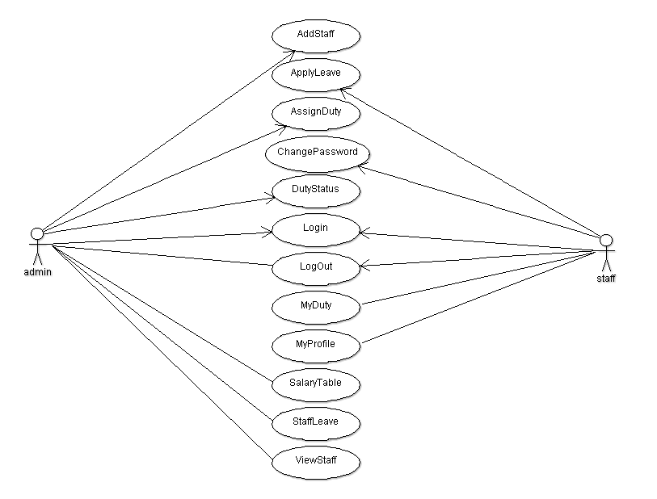
Figure 1: Use case Design
Database Design
The database management system chosen for this project is MySQL. MySQL is a popular relational database management system that is embraced by many larger websites like twitter and Facebook, due to its ability of handling large set of data. MySQL is also very secure.
ADD STAFF
Field Name | Type | Null | Extra | Unique
Id | int (11) |  | AUTO_INCREMENT | YES
First name | varchar(45)
Last name | varchar(45)
Email | varchar(45)
password | varchar(45)
Date of birth | varchar(45)
Gender | varchar(45)
Contact | varchar(45)
Address | varchar(45)
department | varchar(45)
Degree | varchar(45)

LOGIN
Field Name | Type | Null | Extra | Unique
username | varchar(45) |  | AUTO INCREMENT | YES
password | varchar(45)

EMPLOYEE LEAVE
Field Name | Type | Null | Extra | Unique
Id | int (11) |  | AUTO INCREMENT | YES
Token | varchar(45)
Start date | int (11)
End date | int (11)
Reason | Int(11)
Status

ASSIGN DUTY/PROJECT
Field Name | Type | Null | Extra | Unique
Project id | varchar(45)
Employee id | varchar(45)
Project name | varchar(60)
Due date | varchar(10)
End date | varchar(10)
Submission date | varchar(45)
Marks | float
Status

